(Approx. 383 words)

How to Use the Microsoft Word 2010 Quick Parts Feature for Reusable Content
By Mike Layton
Mikesnsltrcntct (at) gmail.com

One Example is Name and Address for Letters

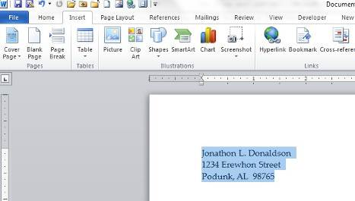
1. Type your name and address the way you want it, and then highlight that text. For example:

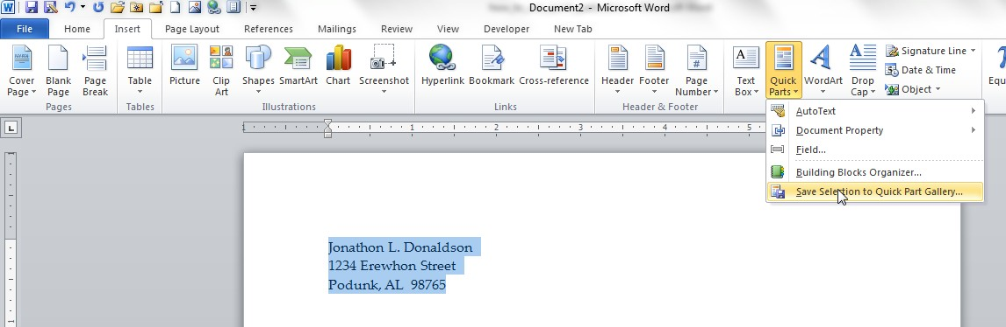
2. Click on the Insert Ribbon (Tab) and then on the Quick Parts tool:

3. With the text highlighted, the “Save Selection to Quick Parts Gallery” option will be available. Click on that option.

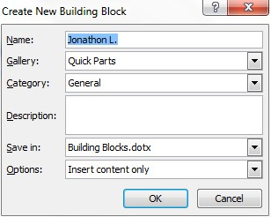
4. You will see the “Create New Building Block” window:

Note that the first few characters of your text were automatically inserted into the “Name” field. However, you can enter any text you want for a name.

If I had entered “John Doe” as the name, the complete name would have been displayed.

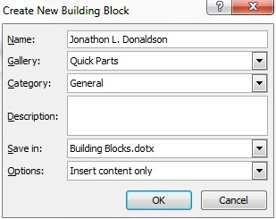
5. For example:

I did not test for a restriction on the number of characters, and it appears, from my limited use so far, that anything over 11 characters is intially truncated.

Now it is a matter of choosing from the options in each of the fields. I have not explored the advantages/disadvantages of the various choices. Here are my choices:

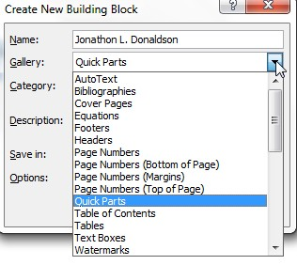
6. The “Gallery” choices are:

I stayed with the default choice, “Quick Parts.”

7. Because I have not used this feature before, the only two “Category” choices are “General” and “Create New Category.” I stayed with the default choice, “General.”

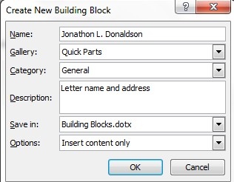
8. I typed in a short “Description”:

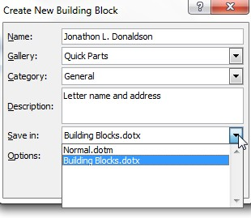
9. The “Save in” options are:

I stayed with the default choice, “Building Blocks.dotx.”

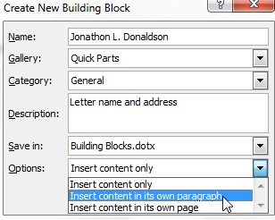
10. The “Options” choices are:

I decided to use the “Insert content in its own paragraph” for this text.

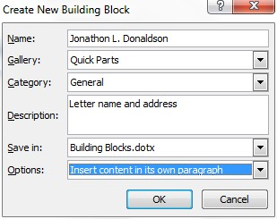
11. My Building Block choices are complete, so I click on OK:

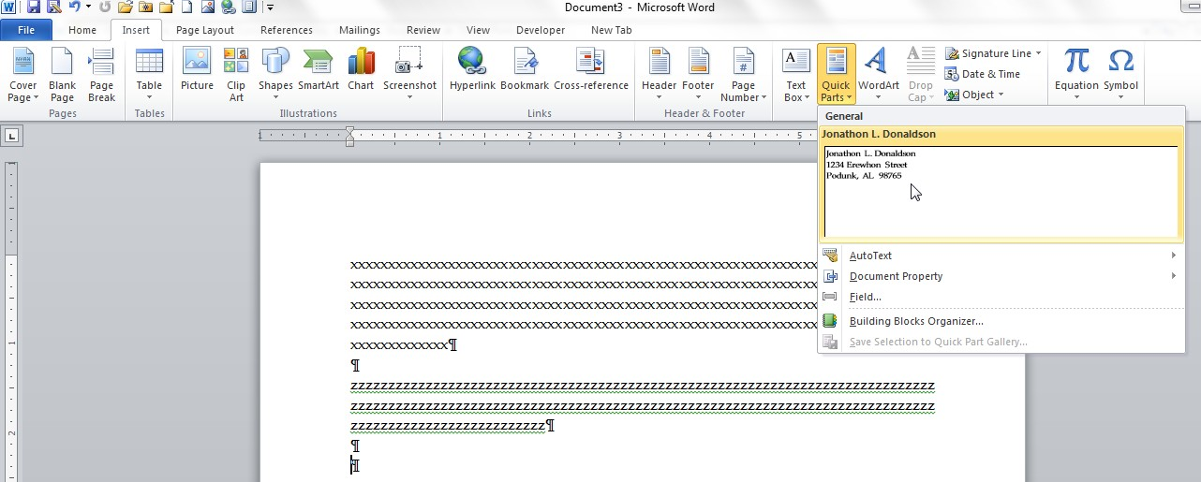
12. The “Create New Building Block” window closes. When I want to insert that Building Block into a letter, I click on the Insert Ribbon/Quick Parts tool:

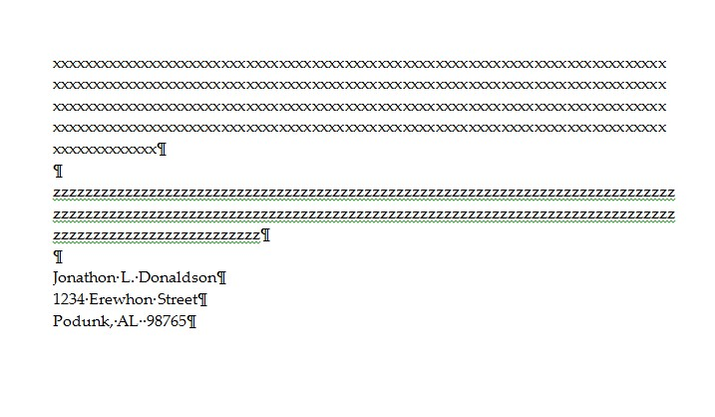
13. Note that my new Building Block is available as the first item in the menu of Quick Parts tools. I click on that and the text is entered into the letter.

Note also that once set up, it only takes 3 clicks to enter the Building Block:

- Click on the Insert tab
- Click on the Quick Parts tool
- Click on the Building Block

